**Title:** Lab 3: Measurement of Diode Characteristics

**Name:** Robert Bara **Partner:** Dalton Hamilton, Mohamad Asaf, Abdulaziz Almersi

**General Objective:** The purpose of this lab is to explore the two-terminal diode component, and their characteristics. This will be done by simulating and analyzing the relationships between voltage and current for a diode.

1. **Background Activities:**

The purpose of a diode is to conduct current primarily in one direction (with the exception of special kinds of diodes such as the Schottky diode). The diode is “forward biased” if voltage at the anode is a larger voltage than the voltage at the cathode, meaning the diode will conduct current without resistance. However, when a diode is “reverse biased”, the voltage at the cathode is larger than the voltage at the anode, meaning that the there should be no current flowing through the diode because theoretically, there is infinite resistance. Diodes can be used to create passive and active phase shifts. Passive phase shifts are accomplished by designing a circuit with inductors or capacitors, as well as getting a phase loop from stray capacitance generated by the circuit or an oscilloscope. Active phase shifts are accomplished when the component heats up from increasing voltage, before the voltage is reduced and cools the diode.

Types of diodes include:

1. The PN Junction diode is a general silicon diode explored within this lab, that attempts to create the ideal diode. This diode can be modelled by examining the I-V curve based upon the approximation,

$$i=I_{s}(e^{v/{VT}}-1)$$

In this equation, $i$ represents the current across the diode, $I_{s}$ is the saturation current of the diode, and $V_{T}$ is the thermal voltage approximated to be $V_{T}=0.082T$, where T is temperature in Kelvin. In this lab, we will assume $V_{T}=25mV$ due to assuming $T=298K$.

1. The Schottky Barrier Diode uses a metal-semiconductor junction instead of a silicon-silicon junction. This allows for faster switching time than the PN diode and contains a lower forward voltage.
2. The Zener Diode is built like the PN junction diode; however, this diode is designed to work within the diode’s breakdown region, generating a “Zener” voltage and providing a predictable current flow.
3. Light-Emitting Diodes (LEDs) are designed to generate light when enough forward current is present.
4. **Procedure**

PART I:

Using Multisim, select a general diode and connect the diode in series to an AC triangular voltage source with $±10V$, a period of $10 ms$, and fall time of $10 µs$. Be sure to ground both components. Add Multisim’s voltage/current probe before flowing through the Diode. Generate a voltage against time curve using Multisim’s transient response with appropriate start and stop times. Record the graph. Change the parameters IS, RS, N and BV found within the diode’s edit model tab and observe how the voltage is affected. Record the graph/results. Finally, change the diode to the BAS16 diode and observe how the voltage varies compared to the ideal diode, be sure to record the graph.

PART II:

Build a circuit to investigate the I-V characteristic of a 1N4148 diode by implementing a source that ranges from -10V to 10V and limit the forward current to about 8mA. Use the values $Rs=50Ω$, $RL=100Ω$, and $Ra=1kΩ.$ Place two differential voltage probes, one across Ra, and one across the diode with respect to ground. Run the transient response and export the graph to excel so an I-V characteristic graph can be generated with the voltage across the resistor as the Y-data (Voltage) and voltage across the diode as the X-data (Current). Repeat the process for two 1N4148 diodes in series.

For analysis, determine why the series combination requires twice the amount of voltage to achieve the same amount of forward current as a single diode. Furthermore, determine what would happen if an additional diode were placed in parallel, and what would the current be?

1. **Results:**
   1. **Simulation Results:**

Below contains the design for a simple ideal diode circuit and its transient response. The transient response initially can be seen as 1 triangle peak of current, peaking at about 8e+153 A, with little to no voltage.

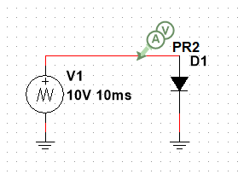

Figure . Circuit built with Multisim's Ideal Diode characteristics

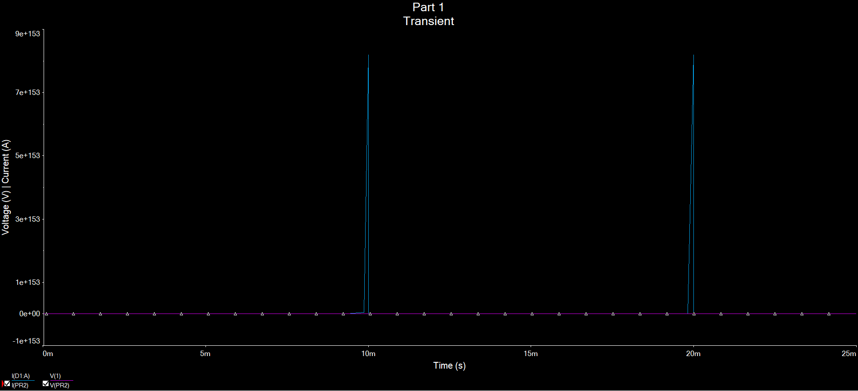

Figure . Transient Response for Circuit 1

Upon using the same circuit, I decided to change each parameter of the diode one by one starting with IS, the generating the transient response shown below. I increased IS from the ideal diode value of 1e-14 A to 2.5e-9 A, which increased the current peak from 8e+153 A to 2.5e+159 A, meaning as IS increases, current increases. The voltage stayed relatively the same according to the graph. Next, I applied a parasitic resistance RS of 0.1Ω, which drastically changed the shape of the graph by increasing the rate at which current increases until it reaches its peak which now sits at 100 A. The voltage also started to increase at a much slower rate than current, until the current decreases. Changing the emission coefficient N from 1 to 10, allowed for a more exponential growth of current, and increased the period between peaks, as the increase is no longer linear. Upon increasing N, the voltage primarily stayed the same, although the current’s peak value decreased from 100A to 70A. Finally, I tried changing the breakdown voltage BV to various values and settled upon 5V, but this was the only value I could not clearly see a change upon simulating in Multisim,

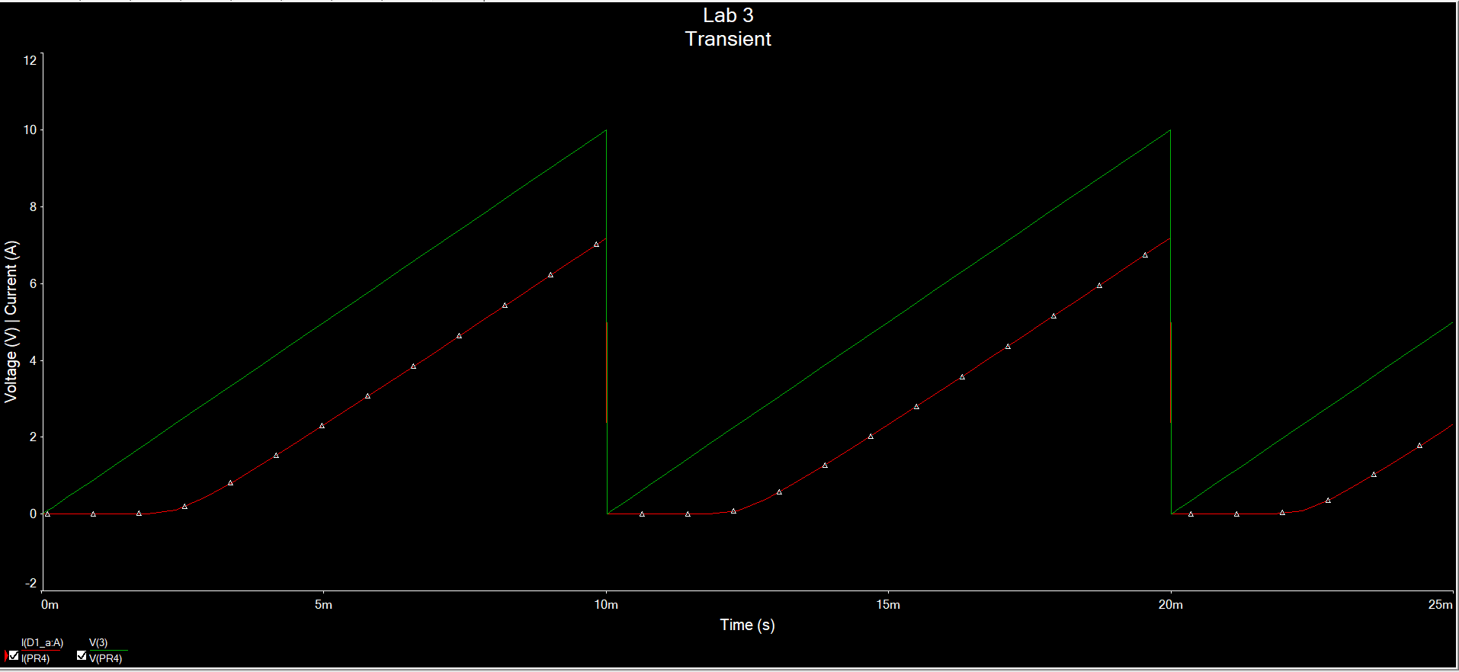

Figure . Transient Response for diode with various parameters

The next circuit I created involved changing the diode to Multisim’s BAS16 diode,

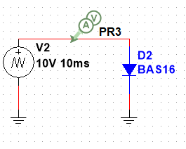

Figure . Circuit with BAS16 diode

Upon recording the transient response, the BAS16 diode acts completely different than the ideal diode. This diode contains a larger voltage wave than current wave, with a peak voltage of 12V and current wave of approximately 6V, meaning the voltage is larger than the current, which was the opposite for the ideal diode. Furthermore, both peaks seem to have a much smaller period than the ideal diode. This diode took nearly 10ms to start increasing to a peak again, however the BAS16 diode starts to increase in voltage and current almost instantly as soon as the peak drops. Interestingly, this graph is similar to when I changed the ideal diode’s RS and N values, thus telling me the BAS16 diode probably has a parasitic resistance, and an N value greater than 1.

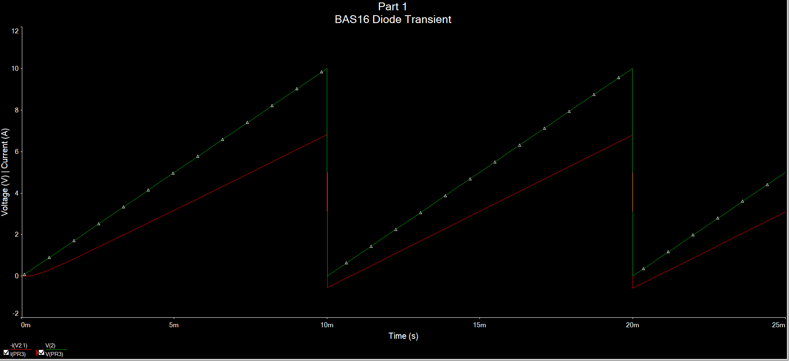

Figure . BAS16 Diode Transient Response

Upon checking the parameters of the BAS16 diode in Multisim, the graph confirms my theory:

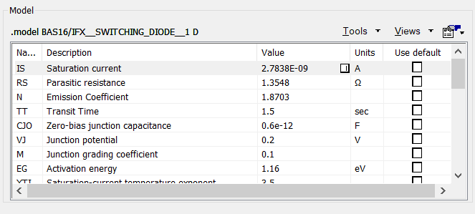

Figure . BAS16 diode's parameters

PART II

The circuit design and I-V curve of the 1N4148 Diode:

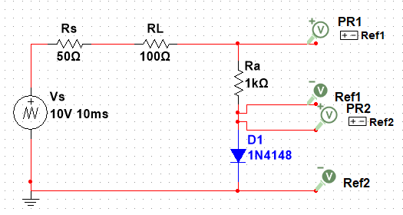

Figure . Test circuit for 1N4148

Two 1N4148 Diodes in Series:

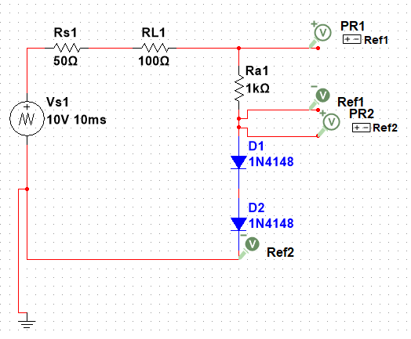

Figure . Two 1N4148 Diodes in Series

2 Diode ins series

1 Diode

Notice that upon adding two 1N4148 diodes in series, the voltage becomes twice as large than the I-V curve for one 1N4148 diode, which had a voltage of 0.6V. Due to ohm’s law, the current also increases upon the voltage increase and increases approximately by 1A.

If we were to build another circuit with the two 1N4148 diodes in series, and another in parallel to the series combination, the circuit and I-V curve would be as follows:

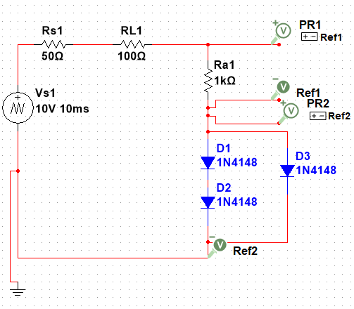

Figure . Circuit with Series and Parallel Diodes

By our test, this makes the most sense since we can model a diode in forward bias by placing a resistor in series with diode, and since the resistor Ra1 is being used to model all three diodes, their voltages would follow the similar characteristics as wiring resistors, in the sense that because of the division of current from KCL, the voltage across an equivalent diode that models two diodes in series with another in parallel, will be less than one diode, whilst the total current will increase.

1. **Conclusion:**

This lab solidified my understanding of pn-junction diodes. The lab explored the relationship of how a diode’s parameters IS, RS, N, and BV can modify the behavior of a diode, in comparison to a general diode, by setting up a simple diode tester to manually obtain the diode’s IV characteristics. Furthermore, the BAS16 diode, which is a small signal fast switching diode, was also explored by comparing the transient response to the transient response of an ideal diode. Upon examining the BAS16, it is clear by the graph that the diode switches faster than the ideal diode.